Arkbird autopilot system

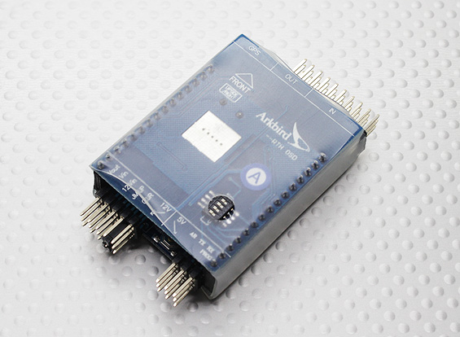

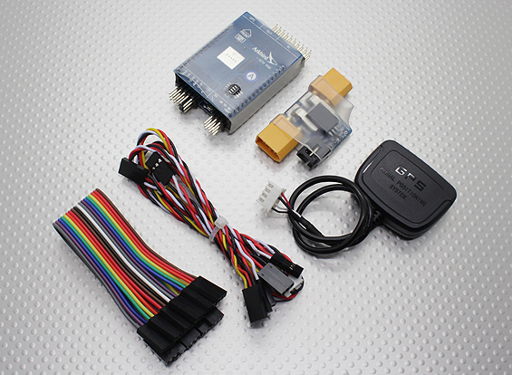

**Features:**• GPS, barometer and attitude sensors to stabilize/control your model's flight  
• Integrated OSD functionality  
• GPS based "Return to Home" functionality  
• 4 point GPS waypoint flight  
• "Cruise Flight" mode offering straight and level flight pattern holding  
• Auto-leveling  
• Easy to setup and adjust

|  |
| --- |
| **Specs: Arkbird Autopilot controller** Dimensions: **50x38x14mm** Weight:**26.5g  Gstar R-15E GPS module** Dimensions:**44x34x12mm** Weight:**19g   Includes:** Arkbird Autopilot System w/OSD GPS module Current sensor All necessary connection cables  PRODUCT ID: 421000001 |

Price=$157.99 weight:250g

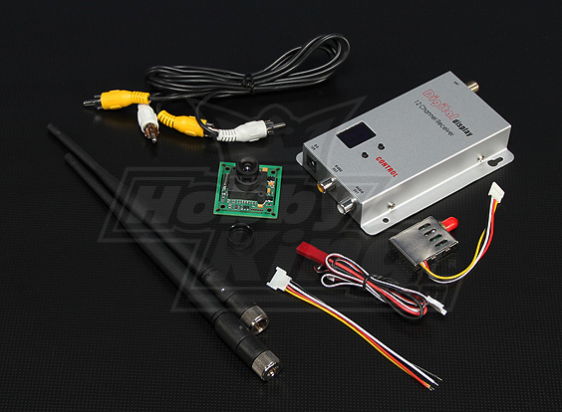

### ****Included.**** 1 x SONY CCD 1/3inch Camera 1 x 900Mhz  4 channel Video Transmitter (200mW)

### 1 x 900Mhz  12 channel Video Receiver

### ****Camera spec.****

### CCD sensor type: ****1/3 color SONY CCD****    Pixel: ****500(H)*582(V) (PAL)**** Scanning system: ****Interlaced scanning**** Synchronization System: ****Internal synchronization**** Horizontal resolution: ****420TV line****    Minimum Illumination ****0.01LUX/F1.2**** DSP+CCD: ****CXD3142R+405AK****  S/N Ratio: ****48dB****    Gamma Modification: ****0.45****    White balance: ****Auto**** Auto backlight compensation: ****Auto**** Lens: ****3.6MM**** Audio: ****No**** Input voltage: ****9~12.6V****  Electric current ****80MA****  Electronic Shutter: ****1/50 (60) ~ 1/100,000s****    Video output: ****1.0VP-P composite video****    Operation Temp.: ****-20~50**** Size: ****38 x 38mm****  Flight time: ****Approx 60min/100mah 3S****

### 

### ****FPV**** ****Tx**** ****Spec.**** Channel: ****4-Ch, AV synchronization****

### Power: ****200mW**** Input voltage: ****12V**** Weight: ****18g****

### Size: ****31x88x8mm**** Frequency: ****0.9G 0.910G,0.980G,1.010G,1.040G****

### PRODUCT ID: CP20012RX4T

PRICE: $50.38